FitPulse: AI-Powered Wellness for University Students

Team Members
• Nirmala Varun
• Sylvano Dsouza
• Madhukar Goli
• Phuoc Long Hoang

Problem Statement & Motivation
University students often face challenges balancing academics, health, and nutrition. Over 60% fail to meet basic physical activity and dietary standards due to lack of access to personalized, flexible routines. Existing fitness/nutrition apps are generic and don’t address student-specific constraints like time, motivation, or resources. FitPulse aims to close this gap by offering a smart, AI-driven platform that dynamically generates personalized weekly fitness and meal plans based on individual go...

Data Sources & Data Science Approach
• Datasets Used:
- Kaggle open datasets: Nutrition Facts, Body Fat Percentage, Workout Planner
- Simulated student data (via Google and Streamlit form)
• Tools & Stack:
- Python (Scikit-learn) for KNN-based recommendation and regression
- R Studio (ggplot2, tidyverse) for EDA and visualizations
- Altair AI Studio for clustering and decision models
- Streamlit (prototype interface)
- JupyterLab for integration & modeling

Evaluation Approach
• Metrics:
- User Satisfaction Score (via simulated surveys)
- Workout Adherence Score (logged workouts vs. plan)
- Nutrient Match Score (vs. USDA guidelines
• Validation Techniques:
- A/B testing using randomized user personas
- Ground-truth comparison of calorie intake vs. prediction

Business Value (Quantified Impact)
FitPulse directly enhances student well-being by promoting consistent fitness habits and personalized nutrition plans. The system combines AI modeling and user feedback to drive measurable improvements in health-related outcomes. Here’s the impact comparison:
Metric | Without FitPulse | With FitPulse
Workout Adherence | 35% | 60%
Nutrient Match Score | 52% | 82%
Overall Wellness Rating | 6.3 / 10 | 8.1 / 10

Long-term benefits include lower campus health costs, improved student mental health, and increased academic engagement.
Visual project plan
• Data collection
• Preprocessing
• Clustering/EDA
• Recommendation generation
• Feedback loop & evaluation
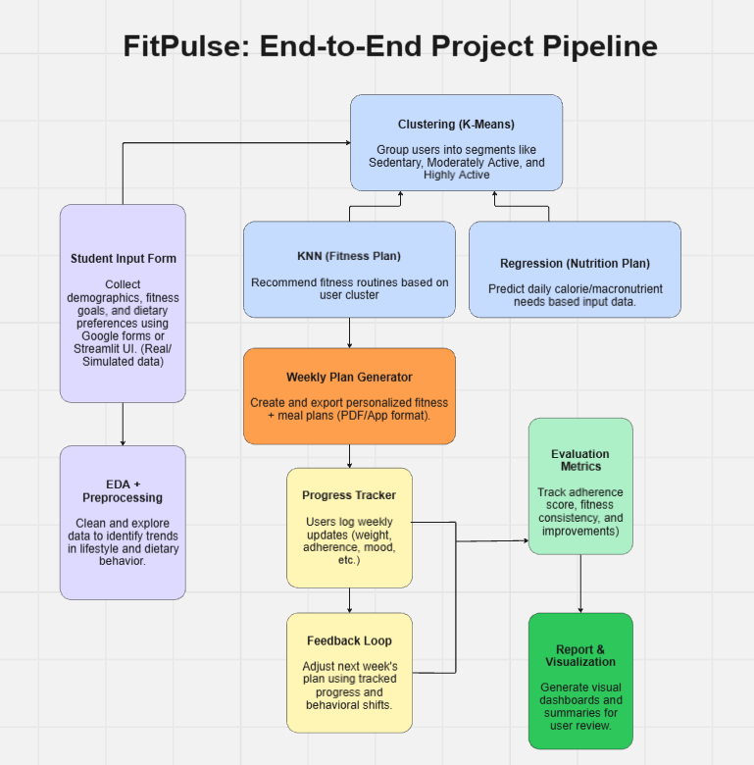

Daily Management Tool
Miro board link

Project Management Sheet

Project Management Sheet - Group 4

